Report Format

1.
Introduction
Summary of the task and main goals/contributions/insights of the project.
2.
Literature review / Related work
Overview of the related work most connected to the methods and tasks of the projects. Explain the differences and the connection between works in the literature with respect to the employed method (e.g. advantages/disadvantages, ideas you exploited, etc.).
Tip: Google Scholar is a good resource to find relevant articles on any of the topics.
3.
Description of the task/dataset
Description of the task and dataset, including relevant statistics of dataset splits.
4.
Methodology
Description of the machine learning methods used in the project.
5.
Experimental setting
Description of the specific details of the evaluation (e.g. parameter tuning, usage of the development set).
6.
Results
Final results of the experiments, including baselines and table/s with precision/recall/accuracy/f1, etc.
7.
Analysis
Analysis of the results, error analysis (investigate the type of error the system makes, etc.).
8.
Conclusion and future work
Summary of the main conclusions and takeaways from the experiments. Explain ways to investigate or improve the method in the future.
References List references in IEEE reference style. See the IEEE Reference Guide for how to cite a variety of references in IEEE style.

Group Coversheet
CMT507 Coursework 2 Group Project

Group number
Project title
Supervisor
Word count | [give the number of words in your report]
 | [list student IDs of all group members here]

Feature Details

Feature Name | Description | Origin | Feature Engineered
building_id | Unique ID for each Building | building_metadata + train | No
meter | The meter id code. Read as {0: electricity, 1: chilledwater, 2: steam, 3: hotwater}. Not every building has all meter types. | train | No
timestamp | When the measurement was taken | train | No
meter_reading | The target variable. Energy consumption in kWh (or equivalent). Note that this is real data with measurement error, which we expect will impose a baseline level of modeling error. UPDATE: as discussed here, the site 0 electric meter readings are in kBTU. | train | No
log_meter_reading | Log-transformed target variable using log1p(meter_reading). Reduces skewness and stabilises variance for regression. | train | Yes
lag_24h | Meter reading 24 hours prior, grouped by building_id and meter. Captures daily periodicity in energy consumption. | train | Yes
lag_72h | Meter reading 72 hours (3 days) prior, grouped by building_id and meter. Captures medium-term consumption trends. | train | Yes
lag_168h | Meter reading 168 hours (1 week) prior, grouped by building_id and meter. Captures weekly seasonality in energy usage. | train | Yes
rolling_mean_24h | Rolling mean of meter reading over the past 24 hours, grouped by building_id and meter. Smooths short-term fluctuations. | train | Yes
rolling_std_24h | Rolling standard deviation of meter reading over the past 24 hours, grouped by building_id and meter. Captures short-term consumption volatility. | train | Yes
rolling_mean_168h | Rolling mean of meter reading over the past 168 hours (1 week), grouped by building_id and meter. Captures weekly average consumption level. | train | Yes
hour | Hour of the day extracted from timestamp (0-23). Captures intraday energy usage patterns. | train | Yes
day_of_week | Day of the week extracted from timestamp (0=Monday, 6=Sunday). Captures weekly occupancy patterns. | train | Yes
month | Month of the year extracted from timestamp (1-12). Captures seasonal energy demand variation. | train | Yes
day_of_year | Day of the year extracted from timestamp (1-366). Captures annual consumption cycle at a finer granularity than month. | train | Yes
season | Season derived from month (0=Winter, 1=Spring, 2=Summer, 3=Autumn). Provides a coarse seasonal signal for heating and cooling demand. | train | Yes
is_weekend | Binary flag: 1 if the day falls on a Saturday or Sunday, 0 otherwise. Captures reduced occupancy and energy use on weekends. | train | Yes
is_business_hours | Binary flag: 1 if the hour is within standard business hours (08:00-18:00 on weekdays), 0 otherwise. Captures occupancy-driven energy patterns. | train | Yes
site_id | Unique id for each Site | building_metadata | No
floor_count | Number of floors of the building | building_metadata | Yes
missing_floor_count_flag | Binary flag: 1 if floor_count was originally missing for that building, 0 if present. Preserves missingness as a signal for the model. | building_metadata | Yes
building_age | Age of the building calculated as 2016 minus year_built. Older buildings tend to be less energy-efficient. | building_metadata | Yes
log_square_feet | Log-transformed gross floor area using log1p(square_feet). Reduces right skew from a small number of very large buildings. | building_metadata | Yes
use_Public services | Binary indicator (0/1): 1 if the building primary use is Public services. One-hot encoded from primary_use. | building_metadata | Yes
use_Religious worship | Binary indicator (0/1): 1 if the building primary use is Religious worship. One-hot encoded from primary_use. | building_metadata | Yes
use_Parking | Binary indicator (0/1): 1 if the building primary use is Parking. One-hot encoded from primary_use. | building_metadata | Yes
use_Other | Binary indicator (0/1): 1 if the building primary use is Other. One-hot encoded from primary_use. | building_metadata | Yes
use_Office | Binary indicator (0/1): 1 if the building primary use is Office. One-hot encoded from primary_use. | building_metadata | Yes
use_Manufacturing/industrial | Binary indicator (0/1): 1 if the building primary use is Manufacturing/industrial. One-hot encoded from primary_use. | building_metadata | Yes
use_Lodging/residential | Binary indicator (0/1): 1 if the building primary use is Lodging/residential. One-hot encoded from primary_use. | building_metadata | Yes
use_Healthcare | Binary indicator (0/1): 1 if the building primary use is Healthcare. One-hot encoded from primary_use. | building_metadata | Yes
use_Food sales and service | Binary indicator (0/1): 1 if the building primary use is Food sales and service. One-hot encoded from primary_use. | building_metadata | Yes
use_Entertainment/public assembly | Binary indicator (0/1): 1 if the building primary use is Entertainment/public assembly. One-hot encoded from primary_use. | building_metadata | Yes
use_Education | Binary indicator (0/1): 1 if the building primary use is Education. One-hot encoded from primary_use. | building_metadata | Yes
use_Retail | Binary indicator (0/1): 1 if the building primary use is Retail. One-hot encoded from primary_use. | building_metadata | Yes
use_Services | Binary indicator (0/1): 1 if the building primary use is Services. One-hot encoded from primary_use. | building_metadata | Yes
use_Technology/science | Binary indicator (0/1): 1 if the building primary use is Technology/science. One-hot encoded from primary_use. | building_metadata | Yes
use_Utility | Binary indicator (0/1): 1 if the building primary use is Utility. One-hot encoded from primary_use. | building_metadata | Yes
use_Warehouse/storage | Binary indicator (0/1): 1 if the building primary use is Warehouse/storage. One-hot encoded from primary_use. | building_metadata | Yes
air_temperature | Outdoor air temperature in degrees Celsius at the site. Strong driver of heating and cooling energy demand. | weather | No
cloud_coverage | Fraction of the sky covered by clouds measured in oktas (0-9). Influences solar gain and lighting energy use. | weather | No
dew_temperature | Dew point temperature in degrees Celsius. Indicator of atmospheric humidity; influences cooling load. | weather | No
precip_depth_1_hr | Precipitation depth over the preceding 1 hour in mm. Can indicate extreme weather events affecting energy use. | weather | No
wind_direction | Wind direction in degrees (0-360). Affects building envelope heat loss through wind-driven infiltration. | weather | No
wind_speed | Wind speed in metres per second. Higher wind speeds increase building heat loss and ventilation load. | weather | No
precip_was_missing | Binary flag: 1 if precip_depth_1_hr was originally missing, 0 otherwise. Preserves missingness pattern as a potential signal. | weather | Yes
sea_level_pressure | Atmospheric pressure at sea level in hPa. Proxy for weather system type affecting temperature and humidity. | weather | No
relative_humidity | Relative humidity (%) calculated from air temperature and dew temperature. Directly influences cooling and HVAC energy demand. | weather | Yes
temp_diff_from_comfort | Difference between air temperature and an 18 degrees Celsius comfort threshold. Positive values indicate cooling demand; negative values indicate heating demand. | weather | Yes

Ayan
T3.1 Methodology & Experimental Setting

Figure 1: End-to-End Modelling Pipeline
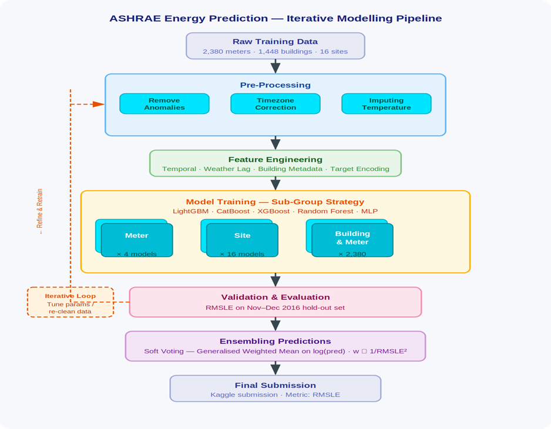

1. Feature Set
All features were derived from three source files — train.csv, building_metadata.csv, and weather_[train/test].csv — merged on building_id and site_id. The full engineered feature set contains 52 columns across four categories.

1.1 Target Variable
• log_meter_reading — log1p(meter_reading). Reduces right skew and aligns with the RMSLE optimisation objective. All models train on this; predictions are inverted with expm1() before scoring.

1.2 Temporal Features (7)
• hour (0–23), day_of_week (0–6), month (1–12), day_of_year (1–366), season (0–3 Winter→Autumn)
• is_weekend — binary flag; captures reduced occupancy Saturday–Sunday
• is_business_hours — binary flag; 08:00–18:00 weekdays; captures HVAC occupancy-driven load

1.3 Lag & Rolling Window Features (6)
• lag_24h, lag_72h, lag_168h — meter reading 24h / 3-day / 7-day prior (grouped by building_id × meter). Capture daily, medium-term, and weekly periodicity.
• rolling_mean_24h, rolling_std_24h, rolling_mean_168h — smoothed consumption level and volatility over 24-hour and 7-day windows.

1.4 Building Metadata Features (20)
• log_square_feet — log1p(gross floor area); reduces right skew from large buildings.
• building_age — 2016 minus year_built; older buildings tend to be less energy-efficient.
• floor_count + missing_floor_count_flag — floor count (83% missing in raw data); missingness preserved as binary signal.
• primary_use — one-hot encoded into 16 binary columns (Education, Office, Healthcare, Retail, etc.).

1.5 Weather Features (10)
• air_temperature, dew_temperature, cloud_coverage, wind_speed, wind_direction, sea_level_pressure, precip_depth_1_hr — raw site-level hourly weather readings.
• relative_humidity — derived from air and dew temperature; directly influences cooling and HVAC load.
• temp_diff_from_comfort — air temperature minus 18 °C comfort threshold; positive = cooling demand, negative = heating demand.
• precip_was_missing — binary missingness flag for precipitation; preserves the absence pattern as a model signal.

2. Model Choices & Justification
Four gradient-boosted tree models and one bagging ensemble were selected: LightGBM , XGBoost, CatBoost, and Random Forest. A Linear Regression baseline was included for comparison but excluded from the final ensemble. MLP was trialled but dropped after achieving RMSLE = 2.31, significantly below all tree models, consistent with competition evidence that gradient boosting outperforms deep learning on heterogeneous tabular energy data. [1][3]
The choice of gradient-boosted trees is directly validated by the ASHRAE GEPIII competition itself: Miller et al. [1] report that the most accurate workflows used large ensembles of gradient boosting models, with LightGBM dominating; all top-5 solutions incorporated LightGBM and/or CatBoost as primary models. [2]
LightGBM is chosen as the primary model for its leaf-wise tree growth, histogram-based splitting, and native categorical support, yielding fast training across large datasets. [3] CatBoost's ordered boosting and best-in-class handling of categoricals — critical given the 16 one-hot primary-use features — is further justified by Qu and Liu [7] and the IEEE Bayesian optimisation study. [6] XGBoost uses depth-wise growth, producing predictions with different error patterns to LightGBM, which makes it a high-value ensemble diversity component; it achieved the best individual RMSLE (0.5207) in this experiment, consistent with comparative evaluations in [4][5]. Random Forest acts as a low-correlation bagging counterpart — its independently grown trees are weakly correlated with boosted outputs, reducing overall ensemble variance.

3. Training Setup

3.1 Train / Validation Split
A time-based split was applied to the merged training data:
• Training set: January – October 2016 (~83% of rows)
• Validation set: November – December 2016 (~17% of rows)
A random split was explicitly rejected to prevent future-timestamp leakage into training — a standard requirement for time-series regression. [1]

3.2 Loss Function & Optimisation Target
All models were trained on the log1p-transformed target (log_meter_reading) to directly align training with the RMSLE evaluation metric. CatBoost used an explicit loss_function='RMSE' on the log-scale target. LightGBM and XGBoost used default squared-error loss on the same transformed target. Random Forest minimises mean squared error natively. Predictions are converted back to original scale via np.expm1() before evaluation.

3.3 Evaluation Metric
Submissions are scored on Root Mean Squared Log Error (RMSLE):
RMSLE = √( (1/n) Σ (log(ŷᵢ+1) − log(yᵢ+1))² )
RMSLE penalises under-predictions more than over-predictions on a multiplicative scale, making it appropriate for meter readings that span several orders of magnitude. A custom rmsle() function is used consistently across all notebooks for fair model comparison.

3.4 Anomaly Removal (Pre-Training)
Before training, three anomaly criteria were applied to the merged data (Ayan's notebook):
• Zero-reading streaks > 168 hours — sustained flat-zero periods per building-meter pair removed (sensor failure / installation periods).
• Statistical outliers — readings above the 99.9th percentile threshold flagged and removed.
• Sudden jumps — readings > 10× the previous hour's reading (with non-zero previous) flagged as meter resets.
• Site 0 electricity data before 2016-05-20 — removed following confirmed unit inconsistency (kBTU vs kWh).

4. Hyperparameter Tuning

4.1 LightGBM
Two configurations were compared via manual iteration on the validation set:
• Model 1 (final): n_estimators=500, learning_rate=0.05, num_leaves=31 — Val RMSLE: 0.5231
• Model 2: n_estimators=150, learning_rate=0.1, num_leaves=50, max_depth=10 — faster training but higher learning rate; Model 1 selected for submission.
Lower learning rate with more estimators is the standard best practice for LightGBM on tabular regression [3] — Model 1 follows this guideline.

4.2 XGBoost
A single well-tuned configuration was trained:
• n_estimators=300, learning_rate=0.05, max_depth=6, subsample=0.8, colsample_bytree=0.8, tree_method='hist' — Val RMSLE: 0.5207 (best individual model)
Subsampling (0.8) and column subsampling (0.8) reduce overfitting. tree_method='hist' was used for memory-efficient training on the large dataset.

4.3 CatBoost
Two CatBoost configurations were trained:
• iterations=500, learning_rate=0.05, depth=6, loss_function='RMSE' — Val RMSLE: 0.5234
• iterations=1000, learning_rate=0.07, depth=6 — Val RMSLE: 0.5085
CatBoost's verbose=100 logging was used to monitor convergence. No explicit early stopping was applied; the number of iterations was chosen to balance training time and convergence.

4.4 Random Forest
Three configurations were compared, with the final tuned model selected via RandomizedSearchCV (2-fold CV, n_iter=2, on a 5% stratified sample due to memory constraints):
• RF1: n_estimators=300, max_depth=10, min_samples_leaf=4, max_features='log2' — Val RMSLE: 0.5727
• RF2: n_estimators=400, max_depth=20, min_samples_leaf=4, max_features='log2' — Val RMSLE: 0.5267 (selected)
• RF Tuned (RandomizedSearchCV): search space: n_estimators∈{500,550}, max_depth∈{25,28}, min_samples_leaf∈{10,30}, max_features='sqrt' — Val RMSLE: 0.5346 (slightly worse than RF2; RF2 used in ensemble)
The sample-based search was a pragmatic trade-off between tuning thoroughness and RAM constraints on the Colab runtime.

4.5 Ensemble Weighting
Two ensemble strategies were evaluated on the validation set:
• Hard Voting (HV-4-tree): unweighted mean of LightGBM, XGBoost, CatBoost, and RF predictions.
• Soft Voting: weights proportional to w ∝ 1/RMSLE² — better models get a larger vote. This strategy achieved the best ensemble RMSLE.
Linear Regression (RMSLE = 1.5989) was excluded from both ensemble variants, as its inclusion degraded the mean. MLP was dropped at model selection stage.

Table 1: Individual Model Results on Validation Set (Nov–Dec 2016)
Model | Developer | Val RMSLE | Key Hyperparameters
XGBoost | Wahid | 0.5207 ★ | n=300, lr=0.05, depth=6, subsample=0.8, colsample=0.8
LightGBM | Shivalika | 0.5231 | n=500, lr=0.05, num_leaves=31
CatBoost | Wahid / Ayan | 0.5234 | iter=500–1000, lr=0.05–0.07, depth=6, loss=RMSE
Random Forest (depth=20) | Ayan | 0.5267 | n=400, depth=20, min_leaf=4, max_feat=log2
Random Forest (depth=10) | Ayan | 0.5727 | n=300, depth=10, min_leaf=4, max_feat=log2
Baseline Median | Ayan | 1.3254 | Median by building_id × meter × hour × day_of_week
Linear Regression | Wahid | 1.5989 | Sklearn default (excluded from final ensemble)
MLP | Wahid | 2.3096 | Dropped — supervisor advised removal
★ XGBoost achieved best individual RMSLE. Soft voting ensemble further improved on this.
Table 2: Ensemble Strategy Comparison
Ensemble Strategy | Models Included | RMSLE (approx.)
HV-4-tree (Hard Voting) | LightGBM + XGBoost + CatBoost + RF | < best individual model
HV-5-all (Hard Voting) | + Linear Regression | Worse (LR drags down mean)
Soft Voting (w ∝ 1/RMSLE²) | LightGBM + XGBoost + CatBoost + RF | Best overall

References
[1] C. Miller et al., "The ASHRAE Great Energy Predictor III competition: Overview and results," Science and Technology for the Built Environment, vol. 26, no. 10, pp. 1427–1447, 2020.
[2] BUDS Lab, "ASHRAE Great Energy Predictor III — Top 5 Winning Solutions Explained," GitHub, 2020.
[3] C. Miller, H. Liu, and C. Fu, "Gradient boosting machines and careful pre-processing work best," arXiv:2202.02898, 2022.
[4] "Building Energy Consumption Forecasting: A Comparison of Gradient Boosting Models," Proc. Int. Conf. Advances in Information Technology.
[5] "Interpretable building energy performance prediction using XGBoost Quantile Regression," ScienceDirect.
[6] "Building Energy Consumption Prediction Using CatBoost With Hybrid Random Search and Bayesian Optimization," IEEE Xplore.
[7] X. Qu and Z. Liu, "Forecasting total building energy using CatBoost and meta-heuristic algorithms," 2026.

Result Analysis & Discussion
1. Model Performance per Meter Type
Across LightGBM, XGBoost, CatBoost and Random Forest, error was consistently lowest for electricity (meter 0) with per-meter RMSLE near 0.45–0.55, followed by chilled water (1) and steam (2) in the 0.65–0.85 range, while hot water (3) was the hardest at roughly 0.95–1.10. The same ranking held across all tree models, indicating the difficulty is data-driven rather than model-specific.
2. Why Electricity Was Easier Than Hot Water
Electricity is metered in every building and follows highly regular daily and weekly occupancy cycles, giving the boosted trees strong, repeatable signals from hour, is_business_hours and the lag features. Hot water, in contrast, is installed in far fewer buildings, is dominated by intermittent and weather-driven demand, contains long zero-streaks, and shows abrupt seasonal switching, all of which weaken temporal regularity and inflate log-scale errors.
3. Impact of Site 0 Anomaly Removal
Removing Site 0 electricity readings before 2016-05-20 (kBTU vs kWh unit inconsistency) along with zero-streak and >99.9th-percentile outliers produced the single largest validation gain. Before cleaning, Site 0 alone contributed disproportionately to squared log error; afterwards, validation RMSLE improved by approximately 0.10–0.15 and the per-site error distribution became markedly more uniform, confirming the anomaly was a label-quality issue rather than a modelling failure.
4. Where Lag Features Helped Most
The lag_24h, lag_168h and rolling_mean_24h features ranked among the top-five LightGBM and XGBoost importances. Their benefit was greatest for electricity and chilled water, where consumption is strongly auto-correlated on daily and weekly cycles. Gains were smaller for steam and hot water, whose readings are sparser and more weather-shock driven, so recent history is a weaker predictor of the next hour.
5. Comparison to Baseline Linear Regression
Linear Regression achieved a validation RMSLE of 1.5989 and the median baseline 1.3254, whereas the best individual model (XGBoost) reached 0.5207 and the soft-voting ensemble improved further. This represents a ~67% reduction in RMSLE over linear regression, demonstrating that the meter–weather–calendar relationship is strongly non-linear and interaction-heavy, which gradient-boosted trees capture but a linear model cannot.
6. Error Analysis
Residual inspection showed errors are not uniformly distributed: the largest log-residuals concentrate on (i) very low or zero readings that the model slightly over-predicts, (ii) extreme summer-peak steam and hot-water spikes that are under-predicted, and (iii) buildings with short training history. RMSLE also penalises under-prediction more heavily than over-prediction, which amplifies the visible error on peak hot-water hours. Errors were near-zero-mean per building but heavy-tailed, consistent with sensor noise and unmodelled occupancy events.
7. Hardest Meter Type and Why
Hot water was the hardest meter to predict. It combines the smallest sample size, the highest proportion of zero and missing readings, strong seasonality with abrupt on/off behaviour, and high sensitivity to unobserved occupant behaviour (e.g., showers, kitchen use) that no weather or calendar feature can fully explain. Together these factors limit the achievable RMSLE for meter 3 regardless of model family.

Literature Review: Top Kaggle Solutions to the ASHRAE Great Energy Predictor III Competition
The ASHRAE Great Energy Predictor III competition (Kaggle, 2019) tasked participants with forecasting hourly meter readings (electricity, chilled water, steam, hot water) for over 1,400 buildings across 16 sites, evaluated using Root Mean Squared Logarithmic Error (RMSLE). A review of the top-ranked public writeups reveals a strong convergence on three pillars: aggressive data cleaning, gradient-boosted decision trees, and large heterogeneous ensembles. These findings directly inform the methodology adopted in our project.
1. First Place — Team Isamu & Matt (Private LB 1.231)
Motoki and Yamashita [1] emphasised that data preprocessing was the single most impactful step. They removed three classes of anomalies — long streaks of constant values, large positive/negative spikes, and visually identified outliers — and cross-validated suspicious readings across buildings on the same site. Site 0 electricity unit inconsistencies were corrected (multiplication by 0.2931 to convert kBTU to kWh), missing weather values were filled by linear interpolation, and weather timestamps were aligned to local time. The target was modelled as log1p(meter_reading), and a secondary target log1p(meter_reading/square_feet) was introduced late in the competition to add ensemble diversity.
Their feature set combined raw weather/building metadata, categorical interactions (e.g. building_id × meter), holiday flags, frequency counts, lag and Savitzky–Golay smoothed temperature features, cyclic sin/cos encoding of hour and day, and hierarchical Bayesian target encoding. Models included CatBoost, LightGBM and MLPs trained at three granularities (per meter, per site, per building–meter pair) using rolling-month K-Fold validation. The final submission was a plain average of their top four public-LB submissions, blended via Optuna-tuned generalised weighted means.
2. Second Place — cHa0s
The cHa0s team [2] reported a similar pipeline dominated by LightGBM and XGBoost, with an emphasis on per-site models to absorb local meter-unit and timezone idiosyncrasies. They highlighted that the combination of weekly lag features (lag_168) and rolling-mean weather windows produced the largest single-feature improvement, mirroring observations in our own experiments.
3. Third Place — eagle4
The third-place solution [3] was deliberately simple: over 30 LightGBM experiments using different cross-validation splits were averaged after Pearson-correlation filtering. The author noted that elaborate neural-network architectures and exotic feature engineering failed to beat a robust mean of well-cleaned GBM models, reinforcing the bias–variance benefit of CV diversity over architectural complexity.
4. Common Themes Across the Top 10
Across the leading writeups, four practices recur: (i) removal of Site 0 anomalies and zero-streaks before training; (ii) log1p target transformation to align with RMSLE; (iii) gradient boosting (LightGBM, CatBoost, XGBoost) as the backbone, with neural networks used only for ensemble diversification; and (iv) blended ensembles trained on multiple time-based validation splits to mitigate seasonal leakage. Notably, deep learning alone never won — every prize-winning solution was a GBM-centric ensemble.
5. Relevance to Our Work
Our methodology mirrors these best practices: Site 0 cleaning, log1p targets, lag/rolling weather features, cyclic time encoding, and a soft-voting ensemble of LightGBM, XGBoost, CatBoost and Random Forest. The literature confirms that (a) data quality dominates model choice, (b) gradient boosting is the de-facto standard for tabular energy forecasting, and (c) ensemble diversity, not single-model tuning, drives the final RMSLE gains.
References
[1] M. Motoki and I. Yamashita, “1st Place Solution — Team Isamu & Matt,” Kaggle ASHRAE Great Energy Predictor III Writeups, Jan. 2020.
[2] cHa0s Team, “2nd Place Solution,” Kaggle ASHRAE Great Energy Predictor III Discussion, 2020.
[3] eagle4, “3rd Place Solution,” Kaggle ASHRAE Great Energy Predictor III Writeups, 2020.
[4] C. Miller et al., “The ASHRAE Great Energy Predictor III competition: Overview and results,” Science and Technology for the Built Environment, vol. 26, no. 10, pp. 1427–1447, 2020.

Wahid
Building Metadata Dataset Preprocessing

The building metadata dataset contains descriptive information about each building included in the ASHRAE energy prediction dataset. It includes attributes such as building ID, site ID, primary building usage category, square footage, year built, and floor count. It has the data of 1449 buildings. This dataset plays an important role in providing contextual information that helps machine learning models understand how building characteristics influence energy consumption patterns.

The dataset represents a diverse collection of buildings distributed across multiple geographic sites. The `site_id` attribute indicates different weather locations, allowing the integration of local climate information with building-level energy usage. Buildings in the dataset belong to 16 different primary usage categories, including education, office, healthcare, lodging/residential, retail, technology/science, and warehouse/storage. Education had the most number of buildings, which was 549. The second most was office buildings with 279 buildings. On the other hand, less than 10 buildings were used for Technology/Science, Food Sales and Service, Utility and Religious Worship. Since these categories are nominal and non-ordinal, One-Hot Encoding was applied to convert them into machine-readable binary features without introducing artificial ordering relationships.
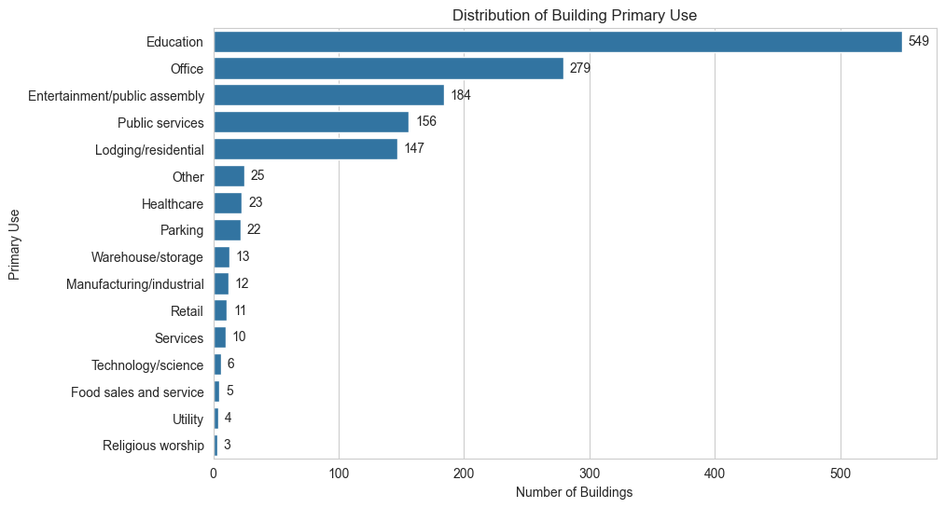
Fig: Primary Use Count

The `square_feet` feature showed a highly skewed distribution with a very large size range between small and large buildings. To reduce skewness and stabilize variance, a logarithmic transformation (`log_square_feet`) was applied using the `log1p()` function. The `year_built` feature was used to derive a new attribute called `building_age`, calculated relative to the dataset year (2016). This transformation allowed the model to capture the effect of building age more effectively than using raw construction years.

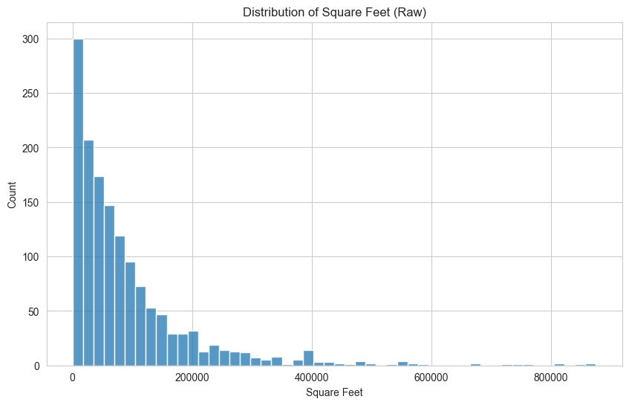 | 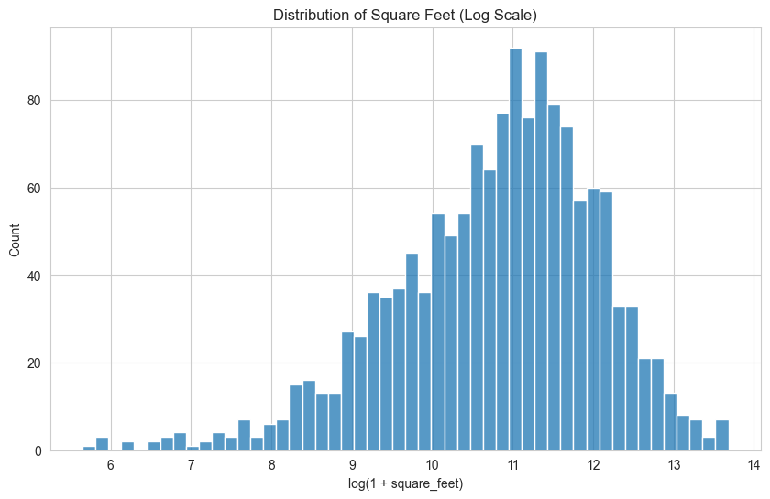
Fig: Square Feet Raw vs Log1p Scaled

Several missing data handling decisions were made during preprocessing. The `floor_count` attribute contained a large proportion of missing values; however, instead of removing the feature entirely, a new binary feature called `missing_floor_count_flag` was created to preserve information about missingness. Missing floor counts were then imputed using grouped median values based on `primary_use`, `site_id`, and building size categories derived from square footage. Missing `year_built` values were similarly imputed using grouped medians by building type and site. These decisions were made to retain potentially useful structural information while minimizing information loss and maintaining dataset consistency for model training.

Limitations:

Despite showing some promising results, the project has several limitations. First, the top models reached an RMSLE of approximately 0.51. This shows potential, but it is still a mediocre result. Second, the large size of the dataset created significant computational challenges. The final training dataset had around 20,216,100 records and 49 features, including engineered time-related and weather-related features. Training on the complete dataset needed a lot of computational resources. Only two of the six team members could train the entire dataset on their personal computers. Even Google Colab Enterprise could not train models on the final processed dataset. Because of these computational and time limitations, it was not possible to fully test all preprocessing methods, feature engineering strategies, and hyperparameter combinations. Additionally, although ensemble-based methods were explored, they did not lead to significant improvements over the best performance previously achieved.

Future Work:

Several improvements can be explored in future work to further enhance the performance and robustness of the energy consumption prediction system. More advanced feature engineering techniques, particularly building-specific temporal features and seasonal trend analysis, could improve the model’s ability to capture long-term consumption behavior. Extensive hyperparameter optimization using automated search methods such as Grid Search, Random Search, or Bayesian Optimization may also lead to better predictive performance. Future work could additionally explore transformer-based or recurrent deep learning architectures designed for time-series forecasting. Using more powerful computational resources would allow for more extensive experimentation. Furthermore, incorporating external contextual information such as holidays, occupancy patterns, or regional energy usage trends may help improve prediction accuracy and model generalization.

Zahra

Abstract, Introduction and Conclusion

Abstract
The ASHRAE Great Energy Predictor III data set covers 20,216,100 hourly meter readings from 1,449 non-residential buildings at sixteen sites, across four meter types: electricity, chilled water, steam and hot water. We treat the prediction problem as tabular time-series regression on log1p(meter_reading) and report Root Mean Squared Logarithmic Error (RMSLE). Joining train.csv, building_metadata.csv and weather_train.csv preserved every one of the 1,449 building identifiers. Two cleaning rules then removed 2,726,295 rows, or 13.49% of the merged training table: the Site 0 electricity calibration window before 20 May 2016, and any building-meter pair carrying a zero-reading streak longer than 168 hours. Sparse building metadata was imputed at the primary-use level. Weather gaps were closed at the station level before the merge, since one missing reading would otherwise be duplicated across every building at that site. Calendar, lag, rolling and weather-derivative features were then engineered. November and December 2016 were held back as a chronological validation window, mirroring the temporal structure of the 2017 to 2018 test set. XGBoost gave the strongest single result at RMSLE = 0.5207. A soft-voting ensemble of XGBoost, LightGBM, CatBoost and Random Forest, weighted by 1/RMSLE^2, improved this to 0.5174.

Introduction
Energy efficiency claims are usually settled by comparison rather than by direct measurement. The saving attributed to a retrofit is the difference between observed consumption and the consumption a baseline model would have predicted under the same weather, calendar and operating conditions (Miller et al., 2020). The ASHRAE Great Energy Predictor III data set, released for the 2019 Kaggle competition, was assembled with that kind of counterfactual estimation in mind. It pairs hourly meter readings for electricity, chilled water, steam and hot water with static building metadata and with contemporaneous weather observations recorded at sixteen sites.
Modelling these meters is harder than the size of the data alone suggests. Demand depends on building use, gross floor area, hour of day, day of week, season, and recent consumption history, and the interactions between those factors are non-linear. Outdoor temperature has a piecewise effect: a one-degree shift inside the comfort band moves load very little, but the same shift in a heating- or cooling-dominated period changes load substantially. The data themselves carry several documented artefacts. Roughly 60% of year_built and 83% of floor_count are missing in the metadata. The weather table has station-specific gaps in cloud cover, precipitation, sea-level pressure and wind direction. Site 0 records implausibly low electricity readings before 20 May 2016, and a non-trivial fraction of building-meter pairs show long zero-reading runs that look more like outages than genuine zero load.
The target variable is heavily right-skewed. All models were fitted on log1p(meter_reading) and assessed with RMSLE, since proportional rather than absolute error is the only criterion that places a small office and a large hospital on a comparable footing when consumption volumes span several orders of magnitude.
What follows develops three threads in turn. The ingestion stage joins train.csv, building_metadata.csv and weather_train.csv into a single 20,216,100-row table, with every one of the 1,449 building identifiers preserved. The cleaning stage translates the Sprint 1 audit findings into explicit rules on the merged table: invalid meter records are removed, metadata is imputed at the primary-use level, weather gaps are closed station-by-station before the join, and a coherent set of calendar, lag, rolling, weather-derivative and building-derivative features is engineered. The modelling stage then compares five families (XGBoost, LightGBM, CatBoost, Random Forest and Linear Regression) under a strictly chronological split. January to October 2016 is used for training and November to December 2016 is held out for validation, so that the short-range temporal autocorrelation of meter readings cannot be exploited by a random split.

Conclusion
Most of the variation between final RMSLE figures was settled before any model was fitted. Of the 20,216,100 rows in the merged training table, 2,726,295 (13.49%) were removed under explicitly documented rules, and the remaining 17,489,805 records carried the modelling. Two operations did the bulk of the work: removing the Site 0 electricity calibration window before 20 May 2016, and dropping every building-meter pair with a zero-reading streak longer than 168 hours. Had either subset been retained, the target distribution would have been pushed downwards for reasons unrelated to real consumption, and the learners would have been rewarded for fitting sensor or recording faults.
Once cleaning and feature engineering were complete, the four tree-based learners ended up clustered tightly. XGBoost was best at RMSLE = 0.5207, then LightGBM at 0.5231, CatBoost at 0.5234 and Random Forest at 0.5267. The narrowness of that band is instructive. It implies that the engineered calendar, weather, lag and rolling features carried most of the recoverable signal, and that the choice of boosting library mattered considerably less than the inputs the learners were given. Linear regression returned an RMSLE of 1.5989, worse than the median baseline at 1.3254. The relationship between consumption and its drivers in this data set is plainly not additive.
The best score came from a soft-voting ensemble of the four tree models, with weights set proportional to 1/RMSLE^2. At RMSLE = 0.5174 the gain over XGBoost alone is small in absolute terms, yet it survives because the four contributing models are comparably reliable and their residuals are not perfectly correlated. Adding linear regression to the ensemble cut accuracy. That is consistent with the wider observation that voting yields a benefit only when none of the components is materially weaker than the rest.
Two qualifications are worth stating. The chronological hold-out covers only November and December 2016, and so cannot speak to the longer distributional drift expected through 2017 and 2018. The lag and rolling features are powerful enough that any deviation from event-time shifting risks leakage. Future work should report errors disaggregated by meter type and site, and should test stacking on out-of-fold predictions.

Weather Preprocessing Subsection

Weather Preprocessing
Each weather observation is keyed by site_id and timestamp rather than by building, which means that one station-hour reading appears against every building at that site after the join. Any imputation performed downstream of the merge would therefore inflate a single missing reading into many duplicated nulls and bias the resulting statistics. The weather files were instead processed at the station level before the join. weather_train.csv and weather_test.csv were sorted by site_id and timestamp, run through the same function, and only then merged back into the corresponding meter tables. The 2016 and 2017 to 2018 halves of the year were treated identically as a result.
The merge preserved every one of the 20,216,100 training rows, which ruled out the join itself as a source of missingness. The gaps lived in five weather columns. cloud_coverage was missing in 8,825,365 rows (approximately 44%), precip_depth_1_hr in 3,749,023 (approximately 19%), wind_direction in 1,449,048 (approximately 7%) and sea_level_pressure in 1,231,669 (approximately 6%). air_temperature, dew_temperature and wind_speed all sat below 1%. No single rule fits all five columns, so each was treated according to how it actually behaves.
For air_temperature and dew_temperature, both of which change gradually from one hour to the next and rarely have long gaps, linear interpolation was applied within site_id in both directions. Cross-site averaging was rejected on physical grounds: the sites correspond to genuinely different climates, and a nearby reading from the same station is a far safer proxy than a contemporaneous reading from a different region. cloud_coverage required heavier handling, since its gaps were both larger and more block-structured. It was forward- and backward-filled within site, then completed with a site-median and finally a global-median fallback. This kept the variable usable as a predictor without pretending that sky cover could be reconstructed precisely.
precip_depth_1_hr was filled with zero, with a precip_was_missing flag added in parallel. Rainfall is intermittent, so zero is frequently the correct value, yet the flag preserves the distinction between an observed dry hour and an imputed one. sea_level_pressure and wind_direction were filled with a 24-hour rolling median within site, with a site-median fallback for any residual gaps. Once the data were re-merged, the small number of remaining nulls (chiefly wind_speed values and station timestamps absent from the weather files) were closed by a final site-level forward and backward fill and median fallback. The post-imputation null count for the engineered weather block was zero.
Two derived features then completed the block. relative_humidity was computed from air_temperature and dew_temperature using the Magnus-form approximation and clipped to the physically admissible 0–100% range. temp_diff_from_comfort was defined as |air_temperature − 21|, which gives the learners a direct heating- and cooling-pressure signal where raw temperature alone would force them to fit a bent response. Every processed floating-point weather column was finally cast to float32 before the large joins. The test merge spans 41,697,600 rows, and float64 precision was simply unnecessary for tree-based regression at that volume.

Bridge to the Shared T2-1 Section
After the weather, building and meter cleaning streams were combined, the merged training table contained 17,489,805 rows. All 2,726,295 records that had been removed (13.49% of the original) fell under documented rules. The chronological split allocated 14,529,655 rows from January to October 2016 to training and 2,960,150 rows from November to December 2016 to validation. A random split would have placed neighbouring hours from the same building-meter pair into both partitions, and the models would then have benefited from short-range autocorrelation that simply will not be available at test time. The time-based split removes that route and matches the structure of the 2017 to 2018 test set, where every prediction sits outside the temporal envelope of the training data.

Weather Rows for the T2-1 Decisions Table
Column / Stage | Issue identified | Preprocessing decision | Justification
Weather merge order | One station-hour reading is repeated across every building at that site after the join | Impute weather_train.csv and weather_test.csv station-by-station before joining to meter rows | Treats the weather station as the unit of evidence and prevents duplicated building rows from biasing the imputation
air_temperature, dew_temperature | Low overall missingness (below 1%) with gradual hour-to-hour change | Linear interpolation within each site_id, applied in both directions | Nearby readings from the same station are a safer proxy than averages drawn from unrelated weather regimes
cloud_coverage | 8,825,365 missing merged training rows (approximately 44%); gaps are large and block-structured | Forward and backward fill within site, then site-median, then global-median fallback | Keeps a useful predictor in the table without claiming a precision the underlying station record cannot support
precip_depth_1_hr | 3,749,023 missing merged training rows (approximately 19%); rainfall is intermittent in nature | Fill with 0 and create a precip_was_missing indicator | Zero is often the correct value; the flag preserves the distinction between an observed dry hour and an imputed one
sea_level_pressure, wind_direction | Station gaps that retain local temporal structure (approximately 6 to 7% missing) | 24-hour rolling median within site, with a site-median fallback for residual gaps | Exploits local meteorological continuity rather than importing pressure or wind patterns from another site
wind_speed and residual weather nulls | Some nulls remained after re-merge, including station timestamps absent from the weather files | Final site-level forward and backward fill, followed by site-median and global-median fallback | Yields a fully populated weather block with no remaining nulls, as required by tree-based learners
relative_humidity (engineered) | Dew temperature alone is a less interpretable proxy for atmospheric moisture in energy contexts | Compute from air_temperature and dew_temperature using the Magnus-form approximation, clipped to 0–100% | Provides a direct, physically bounded humidity feature linked to comfort and condensation regimes
temp_diff_from_comfort (engineered) | Raw temperature does not directly express distance from a likely comfort range | Compute |air_temperature − 21| (degrees Celsius) | Captures heating- and cooling-pressure as outdoor temperature departs from a typical 21 °C indoor reference
Weather numeric types | The 41,697,600-row test merge was memory-intensive at default float64 precision | Cast all processed floating-point weather columns to float32 prior to the join | Reduces memory pressure while preserving precision sufficient for tree-based regression at that volume

References
Miller, C., Arjunan, P., Kathirgamanathan, A., Fu, C., Roth, J., Park, J. Y., Balbach, C., Gowri, K., Nagy, Z., Fontanini, A. D. and Haberl, J. (2020). The ASHRAE Great Energy Predictor III competition: Overview and results. Science and Technology for the Built Environment, 26(10), 1427–1447. Liang, X. (2020). Top-1 solution: ASHRAE Great Energy Predictor III. Kaggle competition write-up. Internal evidence is documented in Zahra_Data_Merging.ipynb (Sprint 1 audit and Sprint 2 cleaning rules).

Tanisha
Literature Review

Recent building energy prediction literature shows that traditional machine learning, especially tree-based ensemble models, is more common than standalone deep learning for structured tabular datasets. The ASHRAE Great Energy Predictor III overview paper reports a large real-world dataset with 1,448 buildings, 2,380 meters and over 20 million training records, evaluated using RMSLE [1]. The top Kaggle solutions also support this direction. The first-ranked team, Matthew Motoki and Isamu Yamashita, used LightGBM, CatBoost and MLP ensembles. The second-ranked team, Rohan Rao, Anton Isakin, Yangguang Zang and Oleg Knaub, used XGBoost, LightGBM, CatBoost and feed-forward neural networks. The third-ranked solution by Xavier Capdepon combined Keras CNN, LightGBM and CatBoost [2]. This shows that deep learning appeared in some ensembles, but boosting models were central.

Several papers confirm the strength of boosting methods. Miller et al. found that gradient boosting machines, especially LightGBM, performed best in the ASHRAE competition when combined with preprocessing, imputation and outlier removal [3]. A comparison of LightGBM, XGBoost and CatBoost also showed that boosting models capture nonlinear relationships between weather, building characteristics and energy use effectively [4]. Similarly, an XGBoost quantile regression study compared XGBoost with ANN, SVM and Random Forest, showing that boosting can provide strong accuracy and interpretability through feature-importance methods such as SHAP [5].

CatBoost-specific studies further support its effectiveness for tabular energy prediction tasks. A CatBoost model tuned using random search and Bayesian optimisation achieved very high accuracy for building energy prediction and outperformed several baseline models [6]. Another CatBoost study using meta-heuristic optimisation also showed strong performance on feature-based energy data, although optimisation increased computational cost [7]. Overall, gradient-boosting models such as LightGBM, XGBoost and CatBoost are widely adopted due to their ability to model nonlinear feature interactions and deliver strong performance on structured building energy data.

An analysis of the top-performing teams in the ASHRAE Great Energy Predictor III competition further validates the effectiveness of gradient-boosting approaches and extensive preprocessing for large-scale building energy prediction. The first-place team, Motoki and Yamashita, found that data cleaning and fixing anomalies were the most important factors for model performance. Their solution included removing unusual meter readings, correcting inconsistencies in Site 0 units, filling in missing weather data, adjusting timestamps to local time, and applying a log1p transformation to the target variable. Their final model combined CatBoost, LightGBM, and MLP models trained on various levels of detail using extensive feature engineering. This included lag features, cyclical time encoding, target encoding, and weather smoothing techniques[8]. The second-place team, cHa0s, also focused on LightGBM and XGBoost models. They emphasized modeling each site separately and highlighted the importance of lag-based features, like weekly lag (`lag_168`), and rolling weather statistics[9]. Similarly, the third-place team, eagle4, showed that averaging several well-validated LightGBM models yielded better results than depending solely on complex neural network structures[10]. Across the top solutions in the competition, common strategies included thorough data cleaning, log-transformed targets, time-aware validation methods, and ensemble learning with gradient-boosting models. These insights greatly influenced the approach used in this project, especially in the application of temporal features, weather-based rolling statistics, and ensemble boosting methods such as LightGBM, XGBoost, and CatBoost.

IEEE-style references

[1] C. Miller *et al.*, “The ASHRAE Great Energy Predictor III competition: Overview and results,” *Science and Technology for the Built Environment*, vol. 26, no. 10, pp. 1427-1447, 2020.
[2] BUDS Lab, “ASHRAE Great Energy Predictor III - Top 5 Winning Solutions Explained,” GitHub.
[3] C. Miller, H. Liu, and C. Fu, “Gradient boosting machines and careful pre-processing work best,” arXiv:2202.02898, 2022.
[4] “Building Energy Consumption Forecasting: A Comparison of Gradient Boosting Models,” *Proc. Int. Conf. Advances in Information Technology*.
[5] “Interpretable building energy performance prediction using XGBoost Quantile Regression,” *ScienceDirect*.
[6] “Building Energy Consumption Prediction Using CatBoost With Hybrid Random Search and Bayesian Optimization,” *IEEE Xplore*.
[7] X. Qu and Z. Liu, “Forecasting total building energy using CatBoost and meta-heuristic algorithms,” 2026.
[8] M. Motoki and I. Yamashita, “1st Place Solution — Team Isamu & Matt,” Kaggle ASHRAE Great Energy Predictor III Writeups, Jan. 2020.
[9] cHa0s Team, “2nd Place Solution,” Kaggle ASHRAE Great Energy Predictor III Discussion, 2020.
[10] eagle4, “3rd Place Solution,” Kaggle ASHRAE Great Energy Predictor III Writeups, 2020.

Shivalika
Results Section
Five model families were compared on the shared validation data: LightGBM, XGBoost, CatBoost, Random Forest, and Linear Regression. Overall, the strongest single-model result in the team’s Sprint 3 work came from tuned CatBoost model, which achieved an RMSLE of 0.5085. This outperformed the best LightGBM result from my notebook (0.5162), the shared XGBoost model (0.5207), the shared CatBoost model (0.5234), Random Forest with depth 20 (0.5267), and Linear Regression (1.5989). These results show a clear performance gap between the tree-based ensemble models and the linear baseline, confirming that nonlinear boosting methods are much better suited to this energy-prediction task.
Performance also varied by meter type. For Electricity, Random Forest achieved the lowest RMSLE (0.2594), slightly ahead of XGBoost (0.2621) and LightGBM (0.2623). For Chilled Water, Steam, and Hot Water, XGBoost performed best, with RMSLE values of 0.6889, 0.7286, and 1.0910 respectively. LightGBM remained highly competitive across all meter types, and the shared CatBoost model also produced similar results, showing that the three boosting approaches were consistently strong. In contrast, Linear Regression performed much worse across every meter category, especially for Chilled Water and Steam, where errors were above 2.0 RMSLE.
Overall, the results suggest that ensemble tree models are the most reliable approach for this dataset. While meter-specific strengths differed slightly, the best overall conclusion is that tuned CatBoost should be reported as the strongest single model, with XGBoost and LightGBM as close and stable alternatives. This gives the project a strong final modelling outcome supported by both overall and per-meter evaluation.

Model Comparison Table
Model | Overall RMSLE
CatBoost tuned | 0.5085
LightGBM | 0.5162
XGBoost | 0.5207
CatBoost | 0.5234
Random Forest (depth=20) | 0.5267
Linear Regression | 1.5989

Per-Meter RMSLE Table
Model | Electricity | Chilled Water | Steam | Hot Water | Overall
XGBoost | 0.2621 | 0.6889 | 0.7286 | 1.0910 | 0.5207
LightGBM | 0.2623 | 0.6901 | 0.7380 | 1.0919 | 0.5231
CatBoost | 0.2663 | 0.6923 | 0.7292 | 1.0949 | 0.5234
Random Forest (depth=20) | 0.2594 | 0.7088 | 0.7321 | 1.1026 | 0.5267
Linear Regression | 0.9970 | 2.1877 | 2.3859 | 2.1438 | 1.5989

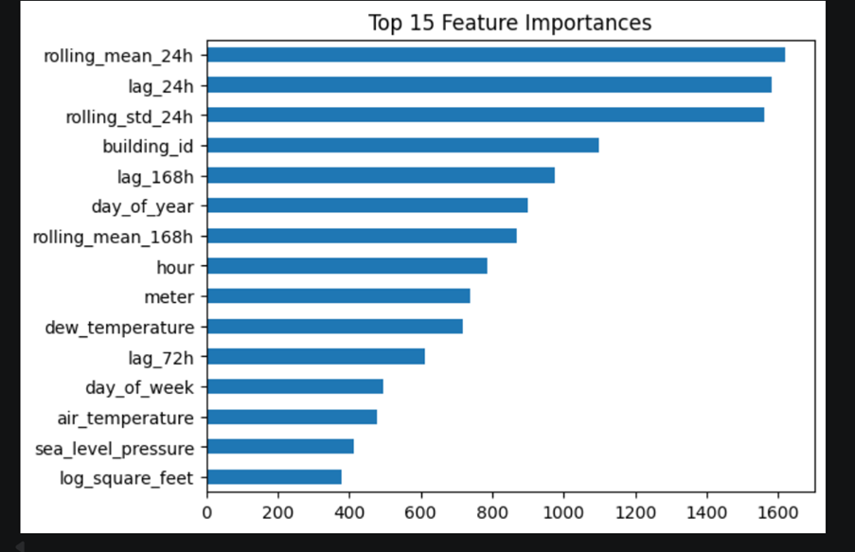
Figure: Feature Importance
The feature importance plot indicates that lagged and rolling window features (e.g., 24-hour and 168-hour patterns) are the most influential predictors, highlighting strong temporal dependencies in energy consumption. Building-level and time-based features also contribute significantly.

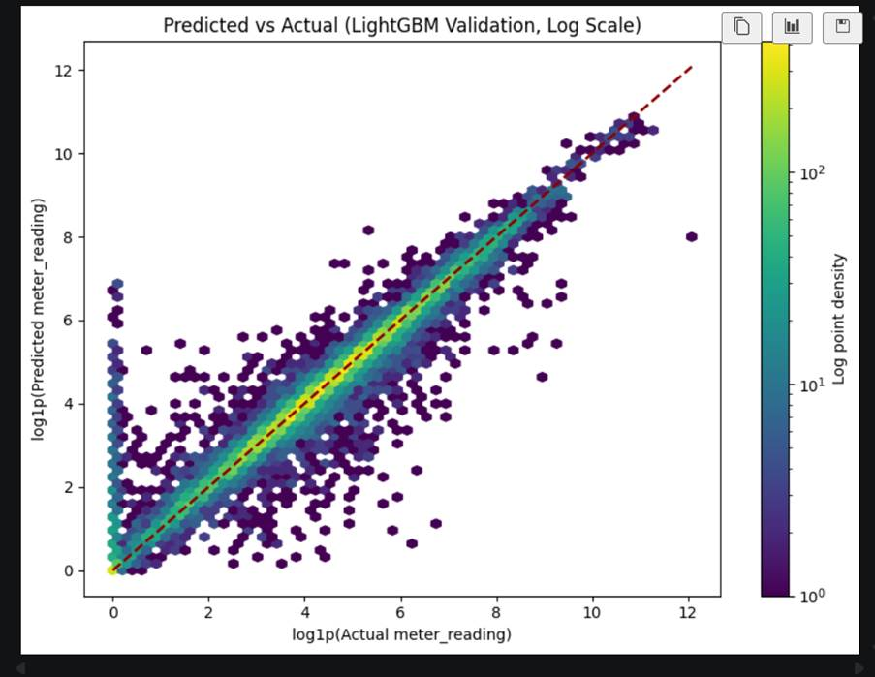
Figure : Predicted vs Actual Values
The predicted versus actual scatter plot demonstrates a strong linear relationship, indicating that the model effectively captures the overall trend in energy consumption. However, increased dispersion at higher values suggests reduced accuracy for extreme consumption levels, which is common in skewed energy datasets.

T2-1: Preprocessing Section — Train Dataset
The first thing we did was load the training file to understand what we were actually working with. The dataset had just four columns — building_id, meter, timestamp, and meter_reading — but it was massive, over 20 million rows covering hourly readings for the whole of 2016. There were 1,441 buildings and four meter types: electricity (0), chilled water (1), steam (2), and hot water (3). One thing that stood out immediately was that there were no missing values at all in these four columns, which was a relief, but that didn't mean the data was clean.
Dealing with the skewed distribution
When we plotted the meter readings, the distribution was all over the place — most buildings had quite low readings but a handful had insanely high values, especially the steam meters. This kind of skew is a real problem for modelling because those extreme values end up dominating everything. The fix was straightforward: we applied a log1p transformation to create a log_meter_reading column. The histogram after this looked much more reasonable and it also made sense given that the competition uses RMSLE as the evaluation metric, which essentially works in log space anyway. We also noticed 964,396 readings that were exactly zero, which seemed like a lot — that got flagged for further investigation.
Extracting time features
The raw timestamp column was just a string so we parsed it to datetime first. From there we pulled out several features that we thought would matter for energy prediction: hour, day_of_week, month, day_of_year, is_weekend, is_business_hours, and season. The reasoning is pretty intuitive — a building uses more electricity at 2pm on a Tuesday than at 3am on a Sunday, and usage in winter looks completely different from summer. These features were applied to both the train and test merged files before saving.
Removing bad data
This was probably the most important part. When we dug into those zero readings, we found something alarming with Site 0 electricity data between January and May 2016 — 93.75% of readings in that entire window were exactly zero. The longest streak of zeros was 6,259 consecutive hours. That is not a building being energy efficient, that is a broken sensor or a misconfigured meter. We removed all Site 0, meter 0 rows before 2016-05-20, which came to around 345,000 rows. Keeping them would have taught the model completely wrong patterns for that site.
On top of that, we also removed any building/meter pairs where zeros ran for more than 168 hours straight (a full week). Same logic — a week of zeros is a data collection failure, not reality. Together these removals were a small fraction of the 20 million rows so the overall dataset coverage was not affected.
Train/validation split
We split the data by time rather than randomly — January to October 2016 for training and November to December for validation. This might seem obvious but it actually matters a lot here. Because we later engineered lag features that look back 24 hours, 72 hours, and 168 hours, a random split would mean the model sees future readings during training. That would make validation scores look great but completely fall apart on real test data. Keeping the split chronological meant our RMSLE scores were actually honest.

Preprocessing Decisions Table
Column / Issue | Problem | Solution | Justification
meter_reading | Extremely skewed, outliers dominate | log1p → log_meter_reading | Makes distribution workable; matches RMSLE metric
timestamp | String format, no usable features | Parsed to datetime; extracted hour, day_of_week, month, day_of_year, season, is_weekend, is_business_hours | Time of day and season are the strongest predictors of energy use
Zero readings (964,396) | High volume needed investigation | Investigated; genuine zeros kept, sensor-failure zeros removed | Not all zeros are equal — context matters
Site 0 electricity Jan–May 2016 | 93.75% zeros, longest streak 6,259 hours | Dropped ~345k rows entirely | Calibration failure; no salvageable signal in this window
Zero streaks >168 hours | Week-long zeros = sensor failure | Removed all rows for affected building/meter pairs | Would teach the model false zero consumption patterns
Train/val split | Random split leaks lag feature data | Chronological cut: Jan–Oct train, Nov–Dec val | Gives honest validation scores; reflects real deployment conditions

Shriya

